**Description**

The big fight between England and Germany was destroyed by the guy called Larrionda. England could have made a tie of 2:2. But that poor guy disqualified Lampard's wonderful goal. The ball passed through the goal line by half a meter, however, Larrionda turned a blind eye to this goal.

As a fan of Three Lion Regimen, silentsky want to develop a system which uses sensors to get the information to check if it scored or not.

The information includes a point as the location of ball, a vector as the velocity and a cuboid as the goal.

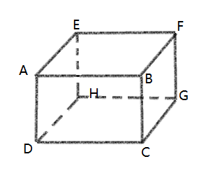

**Input：**

The first line gives an integer t (t<=10000) indicating the number of test cases.

For each case:

The first line gives three real numbers x, y , z, indicating a point to represent the ball.

The second line gives three real numbers a, b, c. indicates a vector to represent the velocity.

The following 8 lines give 8 points according the sequence A, B, C, D, E, F, G, H as is shown in the figure.

Absolute value of all real numbers are smaller than 10000.

It is guaranteed that the initial location of the ball is not inside the goal.

**Output：**

if it scored then output “Case X: Stupid Larrionda!!!”.otherwise output “Case X: Intelligent Larrionda!!!”.(X is the case number starting from 1).

（We consider ABCD as the front of the goal and AB,BC,CD,DA as the goalposts. A shoot scores if and only if it passes through the front of the goal and doesn't crash on the goalpost)

**Sample Input：**

1

20 0 5

-10 5 0

10 0 10

10 10 10

10 10 0

10 0 0

0 0 10

0 10 10

0 10 0

0 0 0

**Sample Output：**

Case 1: Stupid Larrionda!!!